**POP UP --> VIEW DETAILS -UPDATED**

**EDITING REQUIRED**

Our country has completed 75 years of independence and entered the ‘Amrit Kaal’. This ‘Azadi ka Amrit Kaal’ assimilates the pride of thousands of years of our glorious past, the inspirations of Indian freedom struggle and India’s resolve for a golden future .The ‘Amrit Kaal’of 25 years (2022-2047) is the period of the golden centenary of Independence and the making of a developed India. Also, we have completed 52 years of our glorious victory in 1971 Indo-Pak War which is the most commendable and biggest war victory post WWII.

Despite being one of the biggest success of Indian Armed Forces resulting in Liberation of Bangladesh, somehow the current generation of youth is mostly unaware of this saga of victory and valour of the brave soldiers. While talking of the wars, we always talk about the valour and courage shown by the soldiers in the war field but the sacrifice of the family and especially the women remains unnoticed. The event **“Veer Naari Samman Samaroh”** is an endeavor of **Gulmohar Maitri** to glorify and significantly showcase the courage and determination of the unsung Veer Nari and their sacrifice.

**HOME PAGE -UPDATED**

**CLARITY** OF LOGO can be improved

**GULMOHAR MAITRI ---> READ MORE**

1. **ARRANGE** the text (Justify)
2. **REMOVE** **Symbols** before Our Mission, Vision, Objectives

**CHANGE** Cancer Screening & Beneficiary from Health Camp number to make it look more realistic something ….like for example 10058.

**CHANGE font of Phone Number** at the bottom of page to improve clarity.

**ABOUT US**

**In this sequence**

ADD 1 Page for Founder (Secretary) – Arrange text (Justify) **-UPDATED**

ADD 1 Page for President **-Required content**

ADD 1 Page for Brand Ambassador **-Required content**

1 Page for Advisory Board **-UPDATED**

1. Dr.R.N.Singh
2. Dr.J.K.Singh
3. Dr.N.K.Pandey
4. Dr.Shanti Roy
5. Bimal Kumar Jain
6. Dr.Satyajit Kumar Singh
7. Dr.(CAPT.) V.S.Singh
8. Lt.Gen. A.K Chaudhary. (Retd.)

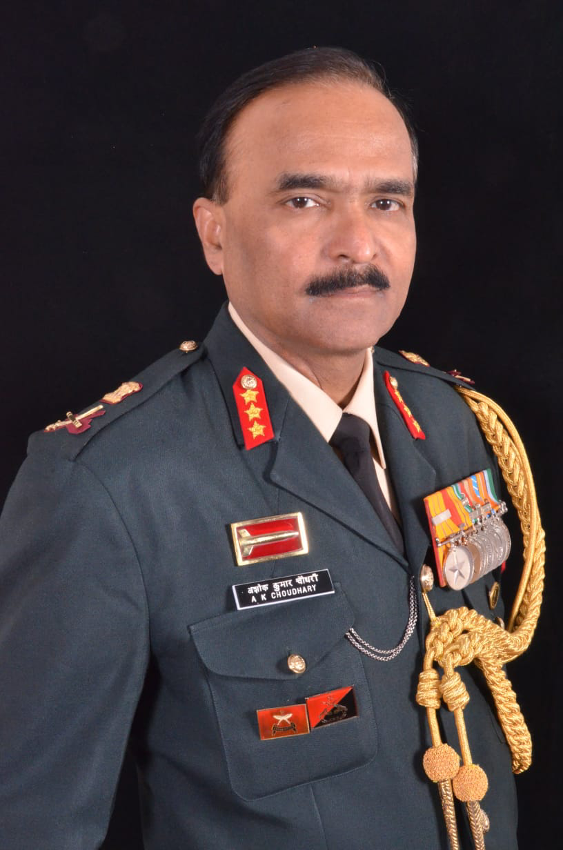

1. Brig. Praveen Kumar (Retd.)

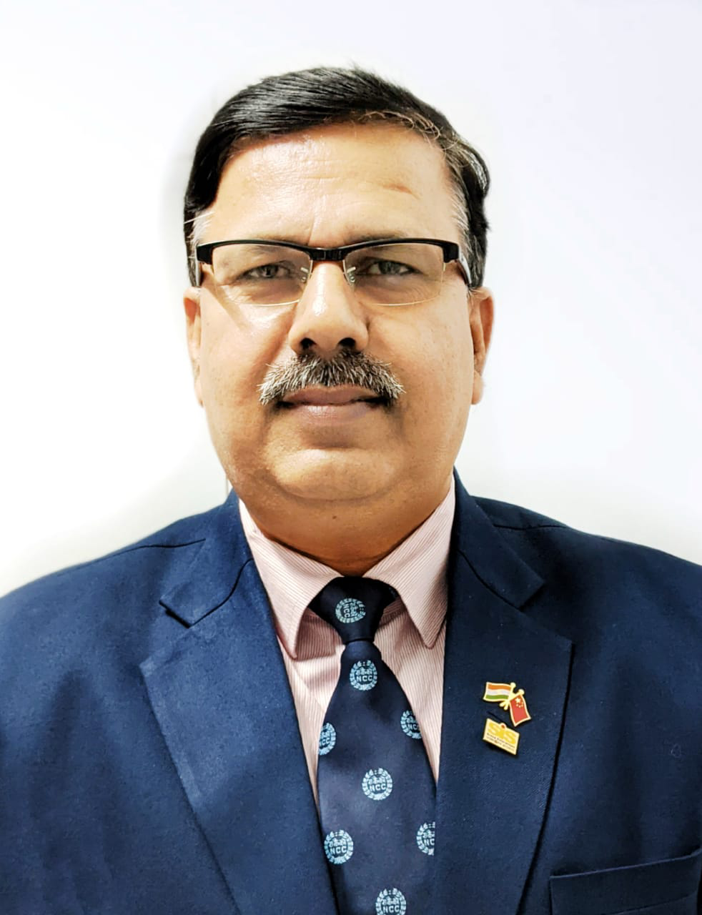

1. Major Sudhanshu Shekhar Pandey (Retd.)

Renowned Lawyer & Legal Advisor Gulmohar Maitri **Required high quality image**

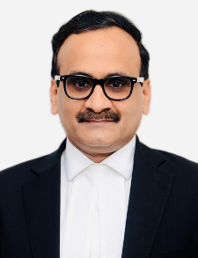

1. Bijay Kumar Kishorepuria
2. Shri Kamal Nopany

Social worker and National Vice President – CAIT

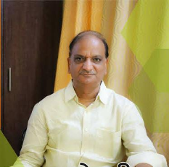

1. Jamshaid Ashraf
2. Rakesh Mishra

CMD Ravian Pharmaceuticals

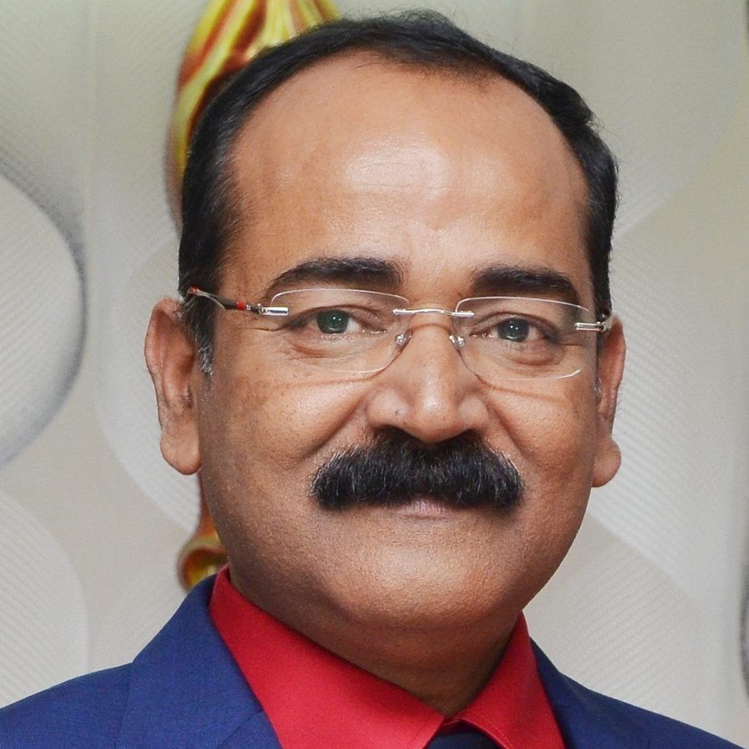

**ADD 1 Page for WORKING TEAM or EXECUTIVE TEAM -UPDATED**

Gulmohar Maitri draws it strength & expertise to execute customized social outreach programs from a dedicated, multi-skilled team of seasoned professionals with wide range of experience. As a team, we are fully equipped to deliver projects for empowering young girls and women by disseminating information, building awareness and conducting activities related to women’s health and hygiene, including Cervical Cancer, Breast Cancer & Menstrual hygiene. Moreover, we are capable to design, execute and manage projects as per contemporary social issues like livelihood & skill development. We believe in achieving new milestones of positive social impact through relevant works & challenging ourselves to achieve excellence.

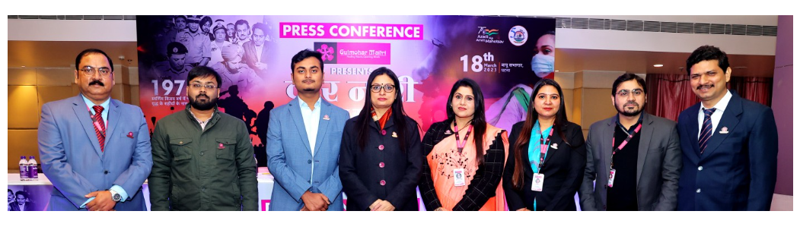

**PARTNERS & ASSOCIATES -UPDATED**

**IMPROVE** LOGO Clarity – some are over stretched e.g. RUBAN

**WHAT WE DO -UPDATED**

**WORK AREAS** – arrange text (Justify) on all 3 pages Breast Cancer, Cervical Cancer & Menstrual Issues

**AMBITION** –**-UPDATED**

Gulmohar Maitrifamily believes in short-term targets that ultimately contribute to achieve the long-term goals. For the upcoming 2 years, in the first phase, we are planning to provide cervical cancer vaccination to **111000** adolescent girls, an ambitious social project initiated in Patna on18 March 2021 with the vaccination of **111** girl children as a token.

**MAITRI CARES -UPDATED**

We all know that humans are a social element and it is our mutual responsibility to help each other in every situation. Standing for others in calamities is the ethos of humanity. Gulmohar Maitri is firmly determined for the betterment of humanity in all possible ways.

Maitri Cares initiative gives opportunity to Gulmohar Maitri to discharge its moral duty towards society. We reach out to underprivileged people and delivers relief during calamities and disasters, relentlessly working for the safety and well-being of the communities and society. Our primary concern and aim is to make all out efforts to mitigate the suffering of needy people during natural calamities and disasters by providing essentials for survival, health and hygiene kits.

**OUR INITIATIVES -UPDATED**

**Improve** text placement (justify) **on all pages under it**, **highlight** in BOLD all data

**MEDIA**

Annual Report – matter to be **added Required content**

Financial Statement – matter to be **added Required content**

**CONTRIBUTE -UPDATED**

**Donation**

**Pay Now** TAB can be changed to **Donate Now**

**Improve** text placement (justify) of Disclaimer

**ADD** bullets/s.no. to make it point wise

**All Adoption Forms – check & improve the fields** of input/information required from website visitor.

Eg. If someone is interested in Donation, there should not be any questions on Educational Qualifications & Interests field should carry options like Health Care, Skill Development, Literacy etc. to help us capture relevant data and use in future for raising more funds.

**Similarly check & improve fields** as required on all forms under Contribution TAB

**Host** - matter to be added **Required content**

**GALLERY** – **Photographs** to be added under all sections. **Required Image**

**EVENTS – information** to be added under all sections.

**CONTACT – -UPDATED**

To work tirelessly for providing access to women on health-related information, education, training, and professional services on menstrual hygiene, breast cancer, cervical cancer and other programs, we continuously need support and feedback to improve ourselves. Take few minutes and help us become more impactful & socially useful.

**After submission** of the information in the form, there should be a **THANK YOU** message.